**Theory and Technology of Robotics**

**Project Proposal**

1. **Introduction of the problem (Motivation and goal)**

For mobile robots, a heated issue is how they can localize themselves where they are probably not familiar with. As the relevant technologies(such as GPS and map services) develops, it seems not a big problem anymore. However, there are some cases where those technologies are not so effective: in buildings, caves, Mars or anywhere the transmission of GPS is weak, or for the places where we need to complete this task with higher precision. So in this project, We want to undertake this topic mainly with and advanced localizing algorithm called *SLAM*, which stands for *simultaneous localizing and mapping*. With this approach taken, we should be able to implement robot localizing task as well as later navigation tasks.

1. **Formulation of the problem**

We want to get the map of the unknown environment and the current position of the robot. We use sensors to get environmental information. Laser radar and camera are the most commonly used sensors. We can quantitative information by the amplitude, phase and frequency of the reflected spectrum or a frame of image. After getting the information of the environment, we detect feature information (landmark) and do feature matching. Use the output of the feature matching, we can calculate the position and orientation of the robot. To reduce the data noise, we do optimization and update coefficients of the system. Then we output the final pose and draw the map. During the whole process, we make close loop closure detection to correct the current pose and reduce the accumulate error.

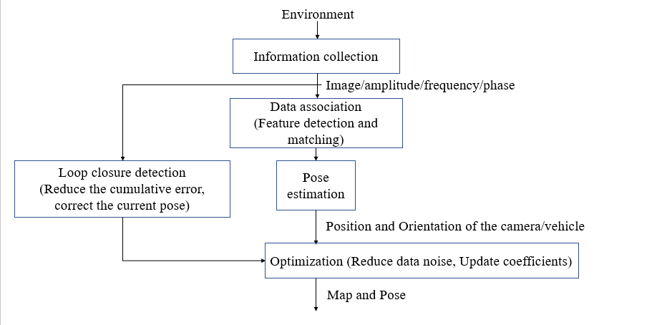

1. **Methods, Toolbox, and Software**
   1. **Method**

For the simultaneous localization and mapping problem, there are mainly three kinds of algorithms: Extend Kalman Filter(EKF), Particle Filter (Mont Carlo Estimator) and Pose Graph Optimization.

1. Extend Kalman Filter(EKF)

For the implementation of EKF in SLAM, the problem is formulated as a state estimation problem and the error is assumed as Gaussian distribution. The state $x$ can have the information of both robot and environment and can be updated by a linearized model with last state. The observation can be used to correct the current state and reduce the enlarging variance.

EKF has mainly two steps: estimation and correction. The estimation is to use the last state and system model to get an estimation of new stage and covariance. The correction is to use the observation to update the estimation with Kalman gain K. Finally, the optimal estimation for the state containing the information of robot and environment can be obtained.

1. Particle Filter

Particle filter is an algorithm that try to get a state that can explain the environment data, it can be used without the assumption that the distribution of error is Gaussian distribution. It used the random state of robot as particles and evaluate how well the particles can explain the current observation then choose the better particle to get to next step.

In this algorithm, the particles are initialized randomly and with the same weight to be chosen, then the particles will go to be updated and resampling in each step. The update of particles can be used by the model of the system then the evaluation for particle can be error form observation. The next step is to update the weight of the particle can be chosen and choose the particles to next stage that can explain better on the observation with the weight.

1. Pose Graph Optimization

The visual SLAM system will accumulate errors with the lack of external control information. To solve such problems, we use the pose graph optimization based Close Loop Enclosure method. In practical applications, the robot may move to the position it has passed before, thus forming a closed-loop constraint. Introducing this constraint to the scanning points passed in the past can obtain globally consistent positioning results, thereby reducing errors.

We will build a close loop enclosure algorithm with the aid of navigation toolbox, we will use lidar scan data to estimate the robot position and Real-time map generation. To simplify the model, we will use feature matching to relate current poses to the previous ones without relative odometry process.

* 1. **Toolbox & software**

Navigation Toolbox™ provides algorithms and analysis tools for motion planning, simultaneous localization and mapping (SLAM), and inertial navigation. The toolbox includes customizable search and sampling-based path planners, as well as metrics for validating and comparing paths. Users can create 2D and 3D map representations, generate maps using SLAM algorithms, and interactively visualize and debug map generation with the SLAM map builder app.

1. **Schedule**

